Press release

Schmersal plans to use recycled material in safety switches

First comparative tests by the Kunststoff-Institut Lüdenscheid (Lüdenscheid Plastics Institute) with positive results

Wuppertal, 13 May 2024. The Schmersal Group is planning to use recycled material in the production of safety switches with plastic housings in future. ‘Our aim is to use 20 per cent recycled material in the switches manufactured using the injection moulding process,’ says Matthias Banaszek, Head of Value Management / Innovation Manager at Schmersal. The first independent analyses now show that Schmersal is well on the way to achieving this goal. The project is part of Schmersal's sustainability strategy with the aim of reducing its CO2 footprint.
To ensure that the recycled material used has no influence on the quality of the safety functions, Schmersal commissioned comparative tests at the Lüdenscheid Plastics Institute. Switches made purely from virgin material were tested in comparison with switches consisting of 80 per cent virgin material and 20 per cent recycled pellets. Three different plastic materials were tested: Ultramid, Hostaform and Frianyl. The results from the Lüdenscheid Plastics Institute are now available: Regranulates made from Ultramid and Hostaform could be used immediately, while further product-related tests are required for Frianyl.
As part of the comparative tests, the Kunststoff-Institut Lüdenscheid examined a number of parameters using standardised test methods, such as the Charpy impact test to DIN EN ISO 179-1, which is used to determine the ductility (or toughness) of a plastic. Or the density measurement according to DIN EN ISO 1183-1 and the contact resistance test according to IEC 60093 to describe the electrical insulation behaviour. The aim was to prove that switches made from mixed materials can withstand adverse environmental conditions just as well as those made from pure new materials. This has been demonstrated for two materials.
The next step is TÜV certification of the safety switches. This will pave the way for series production of the switches with recycled pellets. Schmersal would then be the first manufacturer to use recycled material in safety switches.

Photo:
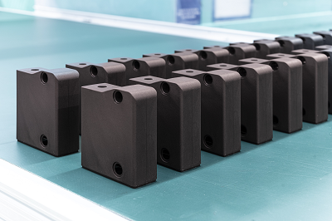
Caption:
The Schmersal Group plans to use recycled material in the manufacture of safety switchgear with plastic housings.

Media contact:
Sylvia Blömker
Tel.: + 49 202 6474- 895
sbloemker@schmersal.com
K.A. Schmersal GmbH & Co. KG
Möddinghofe 30
42279 Wuppertal, Germany

About the Schmersal Group
The Schmersal Group is an international market and expertise leader in the challenging field of machine safety. With the world’s most comprehensive range of safety switchgear products, the Schmersal Group develops safety systems and solutions for special requirements in a variety of user industries. Schmersal’s tec.nicum business division offers a comprehensive service portfolio to complement the range of solutions offered by Schmersal.
Founded in 1945, the company is represented by seven manufacturing sites on three continents with its own companies and sales partners in more than 60 countries. The Schmersal Group employs more than 1900 people worldwide.

www.schmersal.com
www.tecnicum.com

Simply click on this link if you wish to unsubscribe from our press mailing list and no longer wish to receive press releases from Schmersal: Unsubscribe

Information on the data protection regulations at K.A. Schmersal GmbH & Co. KG can be found here

